1. Execute the following program segments on the following singly linked list respectively, and draw the result linked list.

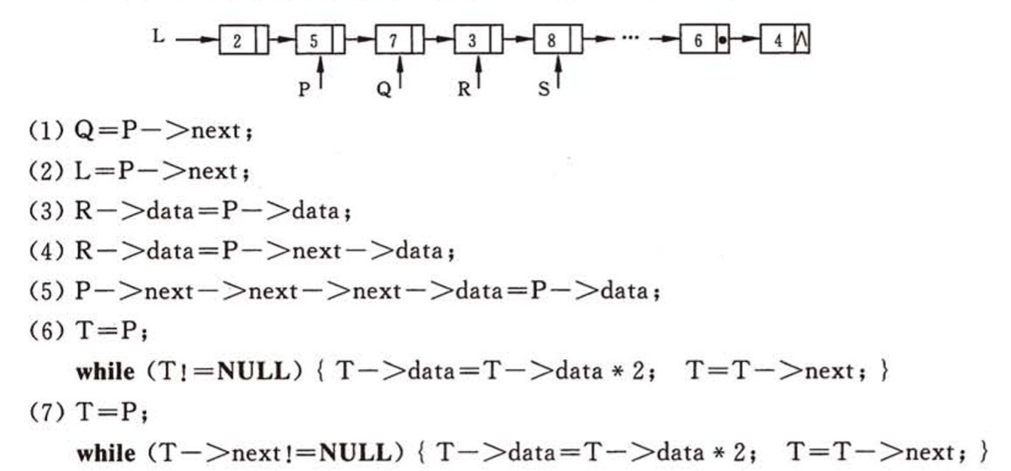

1. Draw a schematic diagram of each pointer and linked list after executing the following statements

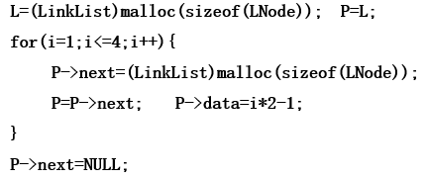

1. Suppose L is a singly linked list without a header node, the node pointed by the pointer P is not the first node and neither the last node. Try to choose correct statement sequence to realize the following operations:
2. Insert a node pointed by the pointer S after the node \*P
3. Insert a node pointed by the pointer S before the node \*P
4. Insert the node pointed by the pointer S into the head of the list
5. Insert the node pointed by the pointer S into the end of the list

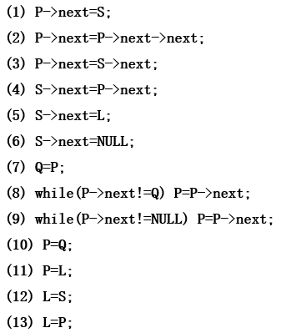

1. Briefly describe the functions of the following algorithms:
2. Suppose L is a singly link list without header node

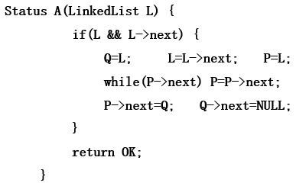

1. Suppose pa and pb point to two nodes in the singly linked circular list,

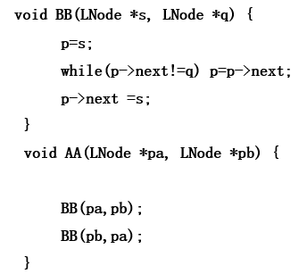

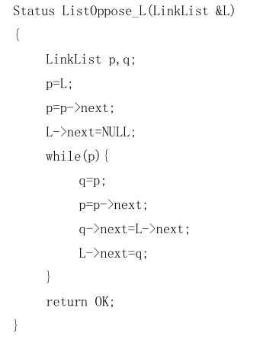

1. void algo1(Stack S){

int i, n, A[255];

n=0;

while( !IsEmpty(S)) { Pop(S, A[n]);n++;}

for (i=0; i<n; i++) Push(S, A[i]);

}

1. void algo2( Stack S, int e) {

Stack T; int d;

InitStack(T);

while(!IsEmpty(S)){

Pop(S, d);

If (d!=e) Push(T, d);

}

While(!IsEmpty(T)){

Pop(T, d)

Push(S, d);

}

}